**Name:** Shubham Golwal

**Roll No.:** 2020300015

**Batch:** TE COMPS-E

**Sub:** HMI

**Experiment No.:** 3

**Name of the Experiment:**

Goal oriented design:Design an experience for passengers whose train is delayed.

**Theory:**

Waiting for a delayed train, missing a connection, or facing a long wait for the next train can be frustrating for passengers. Therefore, an app that provides information on delayed trains and offers suggestions on how to spend time during delays would be helpful. Based on passenger behavior, the app should provide options for entertainment, such as food, games, movies, and maps that show the current location of the train. To ensure a positive user experience, the interface design should prioritize clarity, sequential content, and good color combinations, and provide responsive feedback. Our app is designed to meet these requirements, providing an attractive, user-friendly, and interactive interface to help passengers make the most of their time at the platform during train delays.

**Output:**

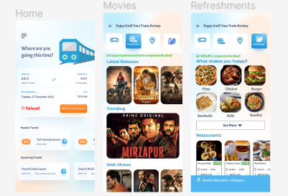

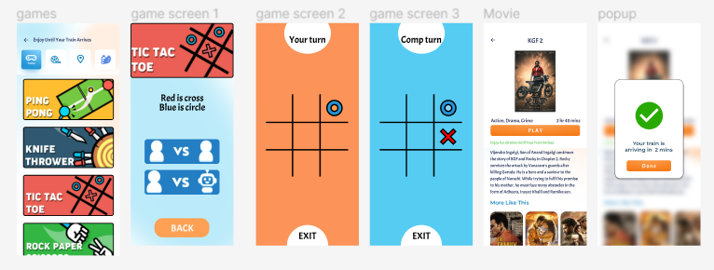

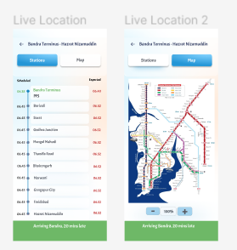

**Conclusion :** In this experiment, we built a ui for an extension to the railway applications, which features to suit the user in times of delay faced by them to keep them engaged by incorporating games, movies, food delivery service and live tracking of the train.